HIGHER EDUCATION
UNIVERSITY OF ECONOMICS AND LAW "KROK"

EDUCATIONAL AND PROFESSIONAL PROGRAM
Second (master's) level of higher education

Business Administration
_____________________________________________________________
(full name of the educational and professional program)

HIGHER EDUCATION LEVEL | second
Field of Knowledge | 07 "Management and Administration"
Speciality | 073 "Management"

APPROVED
Academic Council of the University of Economics and Law "KROK"

Chairman of the Academic Council
____________________ S.M. Laptiev
(Minutes No. 7)
From May 30, 2024

Kyiv – 2024
PREAMBLE
The educational and professional program "Business Administration" for the training of applicants for the second (master's) level of higher education – specialty 073 "Management" was developed in accordance with the requirements of the Laws of Ukraine "On Education" and "On Higher Education".
The educational and professional program is based on the competency-based approach of training masters in the field of knowledge 07 Management and Administration in the specialty 073 Management.
PREFACE

Developed by a working group consisting of:

- Tetiana Mosiychuk, Ph.D., Associate Professor of the Department of Management and Innovative Development, Dean of KROK Business School
- Olga Karpova, Director of KROK Business School
- Oleksandr Kalinin, Doctor of Economics, Professor, Head of the Department of Management and Innovative Development, KROK Business School
- Natalia Kalinina, Ph.D., Associate Professor at KROK Business School
- Oksana Sedashova, Ph.D., Associate Professor at KROK Business School
- Iryna Petrova, Doctor of Economics, Professor, Lecturer at KROK Business School

Reviews-reviews of external stakeholders:
1. Svitlana Nasyrova, Chairman of the Board of the Association of Business Consultants
2. Yevhen Volkov, Ph.D., Master of Business Administration, Director of the State
Enterprise "Research Institute "Orion"

CONSIDERED:
1. The current standard of higher education in the specialty 073 "Management" for the second (master's) level of higher education (Order of the Ministry of Education and Science No. 959 of 10.07.2019)
2. Discussion of the results of internal self-analysis (minutes No. 5 of 27.02.2023), proposals from employers, graduates (minutes No. 4 of 20.02.2023) and students at teacher meetings (minutes No. 6 of 20.05.2023)

- Profile of the educational and professional program "Business Administration"
in the specialty 073_"_Management"
- General information
Full name of the higher education institution and structural unit | Higher Educational Institution "University of Economics and Law "KROK"  KROK Business School
Higher education degree and title of educational qualification in the original language | Second (master's) degree of higher education  Qualification – Master of Management
Official name of the educational program | Business Administration
Type of diploma and scope of educational program | Master's degree, single, 90 credits, term of study 1 year 4 months.
Availability of accreditation of the specialty | Certificate of accreditation series NI No. 1190886, valid until July 1, 2025
Higher education level/cycle | NQF of Ukraine – Level 7  FQ-EHEA – Second Cycle, EQF-LLL – Level 7
Prerequisites | Bachelor's, Specialist's, Master's degree. The rest of the requirements are determined by the rules for admission to study at the University of Economics and Law "KROK".
Language of instruction | Ukrainian, English
Validity of the educational program | 01 July 2025 until the next accreditation
Internet address of permanent posting of the description of the educational program | https://bs.krok.edu.ua/general-mba/
- The purpose of the educational and professional program
Training of highly qualified specialists, managers, senior and middle managers, in the field of management and business administration, who have innovative thinking, all the necessary knowledge and practical skills for the implementation of effective strategic management of companies, able to solve practical problems and act in an unstable competitive environment on the basis of strategies and a project-oriented approach to business management.
- Characteristics of the educational program
Subject area (field of knowledge, specialty, specialization) | - Object of study: management of organizations and their divisions.  - Learning objectives: training of specialists capable of identifying and solving complex tasks and problems in the field of management or in the learning process, which involve research and/or innovation and are characterized by uncertainty of conditions and requirements.  - Theoretical content of the subject area: - paradigms, laws, patterns, - principles, historical prerequisites for the development of management; - concepts of systemic, situational, adaptive, antisipative, anti-crisis, innovation, project management, etc.; - functions, methods, technologies and management decisions in management  - Methods, methods and technologies: - general scientific and specific research methods (calculation and analytical, economic and statistical, economic and mathematical, expert evaluation, factual, sociological, documentary, balance, etc.); - methods of implementation of management functions (methods of marketing research; methods of economic diagnostics; methods of forecasting and planning; methods of designing organizational structures of management; methods of motivation; methods of control; methods for evaluating social, organizational and economic efficiency in management, etc.). - management methods (administrative, economic, socio-psychological, technological); 6 - technologies for justifying managerial decisions (economic analysis, simulation modeling, decision tree, etc.).  - Tools and equipment: modern information and communication equipment, information systems and software products used in management
Orientation of the educational program | Educational-professional/applied. The educational and professional program for the Master's degree is focused on the formation and development of competencies necessary for effective management of business organizations in modern conditions. The program is aimed at providing systemic, critical and strategic thinking, the application of innovative management technologies, risk management, digital monitoring, leadership and consulting on the functioning and development of organizations in the digital age. The structure of the educational and professional program provides for the acquisition of fundamental knowledge by applicants about the patterns of functioning and development of business organizations in the context of digital changes. The program provides a dynamic approach to the study of modern management technologies, tools, methods for developing, analyzing and evaluating the effectiveness of programs for digitalization of management systems, taking into account modern requirements. The program offers a comprehensive approach to the preparation of masters in business administration, which is implemented through a combination of theoretical training and practical training. The educational components of the program are based on modern concepts of management and leadership and are aimed at their practical application in substantiating managerial decisions to increase the competitiveness and efficiency of business organizations, as well as to ensure their sustainable innovative development.
The main focus of the educational program and specialization | Education in Management and Business Administration
Features of the program | - MBA is a program designed to develop holistic, innovative and socially responsible executives and business leaders for organizations with high performance in the global market, developing the knowledge, skills and values necessary to succeed in challenging environments.
- Graduates' suitability for employment and further education
Employability | Master of Management OP "Business Administration" can hold primary positions in accordance with the professional titles of jobs according to the State Classifier of Professions DK003-2010:  14 Managers (managers) of enterprises, institutions, organizations and their subdivisions;  1475.3 Managers (managers) for market research and public opinion research;  1475.4 Managers (managers) for commercial activities and management;  1476.1 Advertising managers (managers);  1477 Managers (managers) for the selection, provision and use of personnel;  149 Managers (managers) in other types of economic activity;  1493 Managers (managers) of quality systems;  1499 Managers (managers) in other types of economic activity, not assigned to other groups.  1210.1 - Director (head, other head) of the enterprise
Academic rights of graduates | They have the right to continue their studies at the third (educational and scientific) level of higher education - Doctor of Philosophy. Acquisition of additional qualifications in the system of postgraduate education.
- Teaching and Assessment
Teaching and learning | Practice-oriented approach in the form of trainings, teamwork, individual presentations by students. The ratio of theory/practice/independent work is 30/40/30. Training is carried out by combining offline and online formats using the MOODLE Platform.
Evaluation | Presentations, tests, reports, practical work, project work, differentiated tests, exams. Final control – exams taking into account the accumulated points of current control according to the rating system of assessment. Attestation is carried out in the form of public defense of the qualification master's thesis.
- Program competencies
Integral competence | Ability to solve complex tasks and problems in the field of management or in the learning process, which involve conducting research and/or implementing innovations under uncertain conditions and requirements
General Competencies (GC) | GC 1. Ability to conduct research at the appropriate level, analyze, synthesize and solve complex unstructured business problems  GC 2. Ability to communicate with representatives of other professional groups of different levels (with experts from other fields of knowledge/types of economic activity)  (by business participants)  GC 3. Skills in the use of information and communication technologies  GC 4. Ability to motivate people and move towards a common goal  GC 5. Ability to act on the basis of ethical considerations (motives)  GC 6. Ability to generate new ideas (creativity)  GC 7. Ability to think abstractly, analyze and synthesize, to know and understand organizations, the external context in which they operate and how they are managed
Special (professional) competencies (SC) | SC 1. Ability to choose and use management concepts, methods and tools, including in accordance with defined goals and international standards;  SC2. Ability to establish values, vision, mission, goals and criteria by which the organization determines further directions of development, develop and implement appropriate strategies and plans;  SC3. Ability to self-development, lifelong learning and effective self-management;  SC4. Ability to manage the organization and its development, to effectively use and develop the organization's resources;  SC5. Ability to create and organize effective communications in the management process;  SC6. Ability to form leadership qualities and demonstrate them in the process of managing people;  SC7. Ability to develop projects, manage them, show initiative and entrepreneurship;  SC8. Ability to develop a corporate strategy of the organization based on a comprehensive analysis of the internal and external environment, to justify the mechanisms for implementing the strategy, to assess its effectiveness;  SC9. Ability to analyze and structure the organization's problems, make effective management decisions and ensure their implementation;  SC10. Conduct mediation activities to reduce conflicts;  SC11. Develop and implement sustainable business development strategies, taking into account environmental and social aspects.
- Program learning outcomes
PLO1. Critically comprehend, select and use the necessary scientific, methodological and analytical tools for management in unpredictable conditions;
PLO2. Identify problems in the organization and justify methods for solving them;
PLO3. Design effective management systems for organizations;
PLO4. Justify and manage projects, generate entrepreneurial ideas;
PLO5. Plan the activities of the organization in strategic and tactical contexts;
PLO6. Possess skills in making, justifying, and implementing managerial decisions under unpredictable conditions, taking into account the requirements of current legislation, ethical considerations and social responsibility;
PLO7. Organize and carry out effective communications within the team, with representatives of different professional groups and in an international context;
PLO8. Apply specialized software and information systems to solve organizational management problems;
PLO9. Be able to communicate in professional and scientific circles in state and foreign languages;
PLO10. Demonstrate leadership skills and ability to work in a team, interact with people, influence their behavior to solve professional problems;
PLO11. Provide personal professional development and planning of your own time.
PLO12. Be able to delegate authority and manage an organization (or its subdivision);
PLO13. Be able to plan and implement informational, methodological, material, financial, and personnel support for an organization (or its subdivision)
8. Resource support for the implementation of the program
Staffing | Full-time employees of the university, leading teachers of academic scientific institutions, teachers of practice who meet the qualification requirements in accordance with the specialty are involved in teaching.
Logistics | Complies with the licensing conditions for conducting educational activities: − educational multimedia classrooms; − computer laboratories; − library, including reading room; − gyms; − dining room; − hostel; − medical center. Available access to the "YouControl" database
Informational and educational support | Complies with the licensing conditions for conducting educational activities. To access the educational and methodological support of disciplines, the Moodle platform is used.
9. Academic mobility
National Credit Mobility | Under academic mobility programs within the framework of programs and/or agreements between KROK University and higher education institutions of Ukraine.
International credit mobility | Under academic mobility programs within the framework of programs and/or agreements between KROK University and foreign higher education institutions.
Training of foreign applicants for higher education | According to the rules of the Ministry of Education and Science of Ukraine and the rules of admission to KROK University.

- List of components of the educational and professional program and their logical sequence
  - List of components of the EPP
N/A code | Components of the educational program (academic disciplines, course projects (works), practices, qualification work) | Number of credits | Form of final control
1 | 2 | 3 | 4
- Mandatory components of the EPP
MC1 | Project management and time management | 3 | Passed
MC2 | Managerial economics | 3 | Exam
MC3 | Marketing Management | 3 | Exam
MC4 | Management in organizations | 3 | Passed
MC5 | Strategic management | 3 | Exam
MC6 | Business legal environment | 3 | Exam
MC7 | Communicative Management | 4 | Passed
MC8 | Risk Management | 3 | Passed
MC9 | Organizational behaviour | 3 | Passed
MC10 | Research in Modern Management | 3 | Exam
MC11 | Managerial Accounting and Financial Management | 7 | Exam
MC12 | Creative and Innovative Management | 3 | Passed
MC13 | HRM & resilience | 3 | Exam
Total Required Components |  | 51
2. Elective components of the EPP
EC1 | 1. Elective course 1  2. Elective course 2 | 5 | Passed
EC2 | 1. Elective course 1  2. Elective course 2 | 5 | Passed
EC3 | 1. Elective course 1  2. Elective course 2 | 6 | Exam
EC4 | 1. Elective course 1  2. Elective course 2 | 3 | Exam
EC5 | 1. Elective course 1  2. Elective course 2 | 4 | Passed
Total volume of elective components |  | 23
3. Components of practical training
PT 1 | Pre-graduation practice | 8 | Passed
PT 2 | Qualification master's thesis | 15 | protection
Total Scope of Practical Training Components |  | 16
Total volume of the educational program |  | 90

  - Structural and logical scheme of the Educational and Professional Program
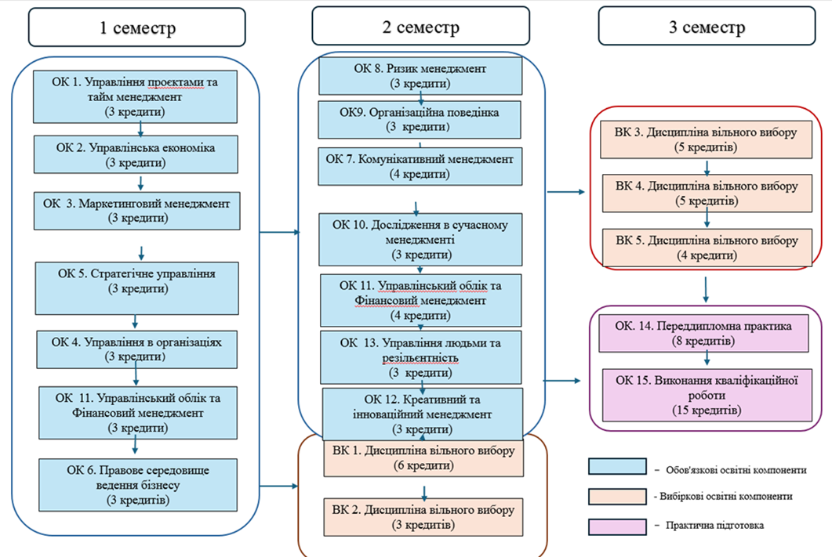

- Forms of attestation of applicants
Forms of attestation of higher education applicants | Attestation is carried out in the form of public defense of the qualification master's thesis
Requirements for qualification work | The qualification master's thesis should provide for the solution of a complex problem or problem in the field of management, a task or problem in the field of management, which requires research and/or innovation and is characterized by complexity and uncertainty of conditions, using theories and methods of economic science. The qualification master's thesis must not contain academic plagiarism, falsification, fabrication. The qualification master's thesis must be published on the official website of the higher education institution or its subdivision, or in the repository of the higher education institution.  .

- Matrix of correspondence of program competencies to the mandatory components of the educational program

 | MC1 | MC2 | MC3 | MC4 | MC5 | MC6 | MC7 | MC8 | MC9 | MC10 | MC11 | MC12 | MC13 | PP 1 | PP 2
GC 1 | + | + |  |  |  |  |  | + | + | + |  |  |  | + | +
GC 2 |  |  | + |  |  | + | +
GC 3 | + |  |  |  |  |  |  |  | + |  | + | + |  | +
GC 4 |  |  |  | + | + |  |  |  |  |  |  |  | +
GC 5 |  |  |  |  |  | + |  | +
GC 6 | + |  | + |  | + |  |  |  | + |  |  | +
GC 7 |  |  |  | + |  |  |  |  |  | + | + |  | + |  | +
SC1 | + |  |  |  |  | + |  | + | + | +
SC2 |  |  | + | + |  |  |  |  | + |  |  |  |  |  | +
SC3 |  |  |  |  |  |  |  |  |  | + |  |  | + | + | +
SC4 |  |  |  | + |  |  |  | +
SC5 |  |  | + |  | + |  | + |  |  |  |  |  | + |  | +
SC6 |  |  |  | + | + |  |  |  |  |  |  |  | +
SC7 | + |  |  |  |  |  |  |  |  | + |  | + |  | +
SC8 |  | + |  |  |  |  |  |  | + |  | +
SC9 | + |  |  |  |  |  |  | +
SC10 |  |  |  |  | + | + |  |  |  |  |  |  | +
SC11 | + |  |  | + |  |  |  |  | + |  |  |  |  | + | +

- Matrix for Providing Program Learning Outcomes (PLO) with the appropriate mandatory components of the educational program

 | MС1 | MC2 | MC3 | MC4 | MC5 | MC6 | MC7 | MC8 | MC9 | MC10 | MC11 | MC12 | MC13 | PT 1 | PT 2
PLO1 |  | + |  |  | + | + |  |  | + |  |  |  |  | + | +
PLO2 | + |  | + |  | + |  |  | + | + | + |  |  |  | + | +
PLO3 |  | + |  | + | + |  |  | + | + |  |  |  |  | + | +
PLO4 | + |  |  |  | + |  |  |  |  | + | + | + |  | + | +
PLO5 |  | + | + |  |  |  |  |  | + |  |  | + | + |  | +
PLO6 | + |  | + |  |  | + |  | + |  |  |  |  |  | + | +
PLO7 |  |  | + | + |  |  | + |  |  |  |  |  | + | +
PLO8 | + |  |  |  |  |  |  |  |  |  | + |  |  |  | +
PLO9 |  |  |  |  |  | + | + |  | + | + |  |  |  | +
PLO10 |  |  |  | + | + |  | + |  |  |  |  | + | +
PLO11 | + |  |  |  |  |  |  |  | + | + |  |  | + | + | +
PLO12 |  |  |  |  | + |  |  |  |  |  |  |  | +
PLO13 |  | + |  |  |  |  |  | + |  |  | + |  |  | + | +

